Software Deployment Project

Student Name: Panashe Madakasi

Student ID:30000916

Date:2/12/2020

Contents

Introduction 1

Development Methodology 1

Project Plan 1

Collaboration Environment 2

Source Control 2

SQL Statements 3

Installation Method 4

Installation instructions: 4

System requirement 5

Creating an Installation Package 5

Installation Plans 5

Removing The program 7

Database Deployment 7

Application Configuration 7

# Introduction

Th program being deployed is a DVD Search app application, the application connects to a movie database. The application has a text field that is use for searching for movies using their keyword.

# Development Methodology

Because the project is quite simple and a small size, the methodology being used is the waterfall methodology this allow the planning for the project plan to be straight forward, based on the requirement given the waterfall methodology will be the best choice.

# Project Plan

For the project plan Microsoft project was used, the project plan outlines all tasks required for the program’s development. The project plan shows every in the team’s task, when it should start and deadlines.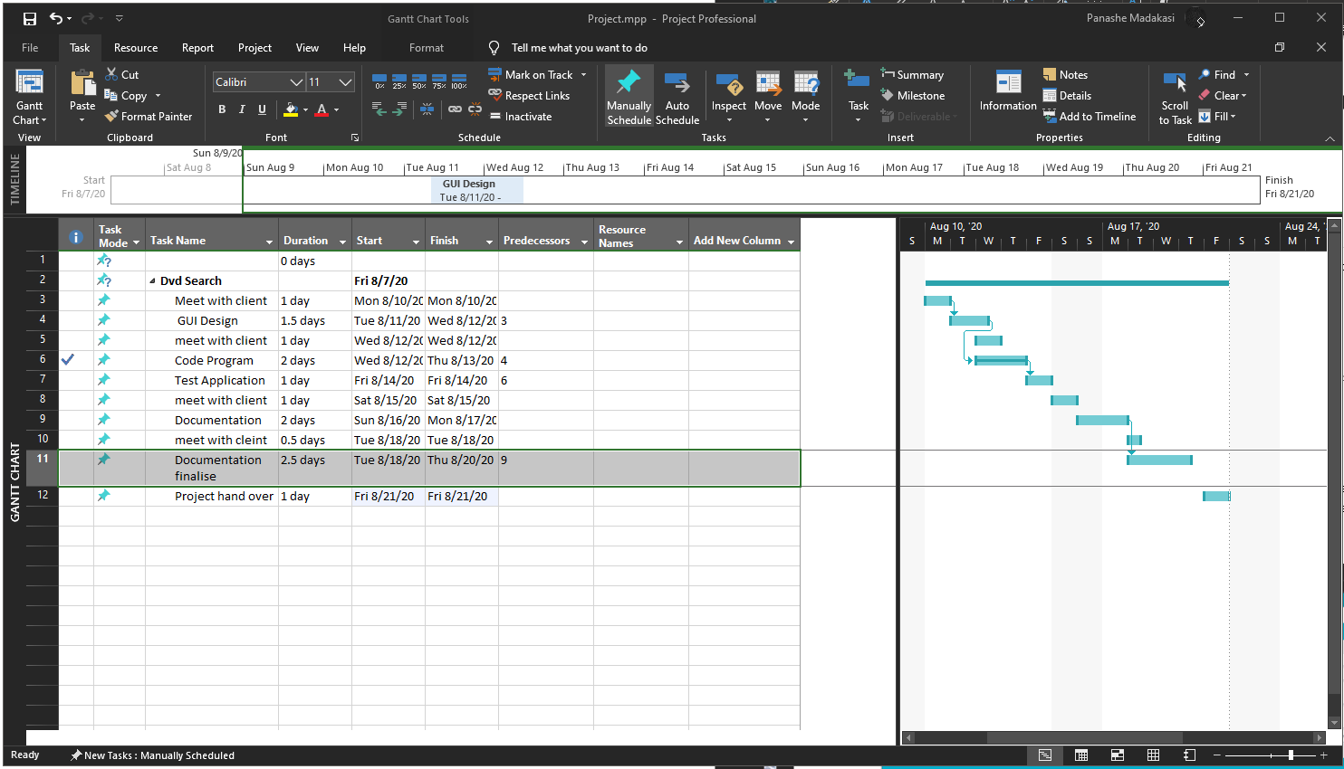

# Collaboration Environment

I have chosen to use trello as the collaboration environment for the development of the application, because of Trello’s simple layout trello is easy to use and fast to lean. Trello allows for column which are used to track the progress of each task.

Trello Link: https://trello.com/b/dxB3RF4r/dvd-search-app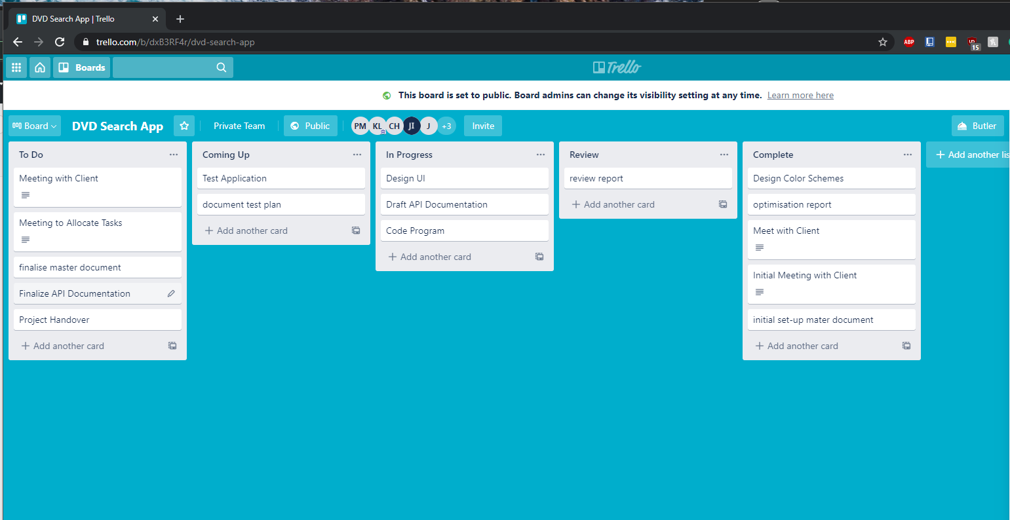

# Source Control

For the source Control GitHub is used, this source control will be used to store the source files of the program and all the documentation.

URL: https://github.com/PanasheKM/DVD-Search-App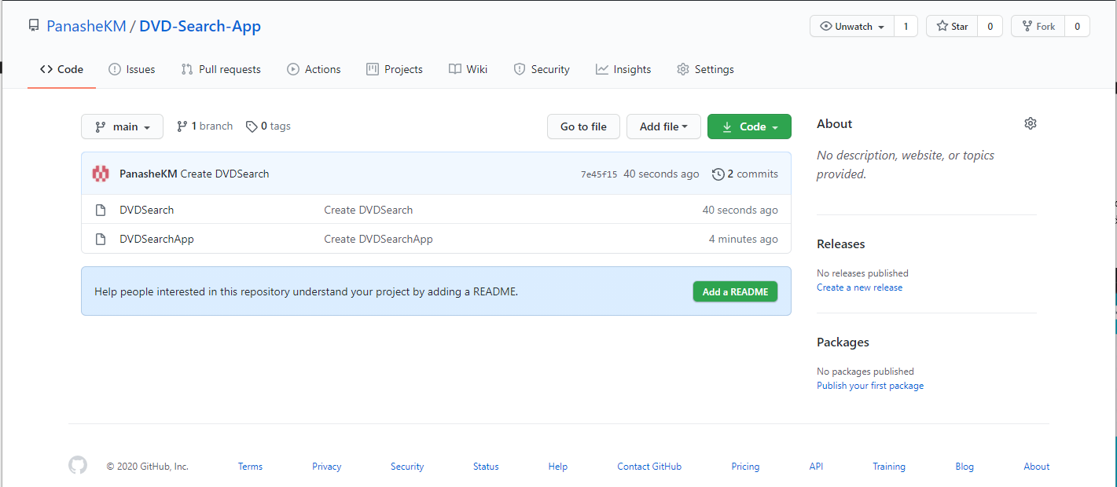

# SQL Statements

This These SQL statements are from the Move Title.xls, This sql Document is used to import all movie titles to a database

|  |
| --- |
|  |
|  |

Activity Two

# Installation Method

The installation method for the program could be done using an executable jar file, the executable jar file packages all files contained for the java move search program. For deploying the program clients could attain the program though a download link on a website alternatively because the size of the program is quite small the deployment method could be thought email as well.

# Installation instructions:

Xampp – The program being used to run the database so use of this application is needed

* Download and install Xampp.
* Open the Xampp application and you will be greeted with a control panel.
* Press start for Apache and the MySQL modules and they should light up green when their on.
* Now press the Admin button on the control panel and a internet browser will open taking you to this webpage Link: <http://localhost/phpmyadmin/>
* Now in the PhpMyAdmin webpage, on the top bar there will be a import button Click and a new page will be presented.
* Click the “Choose File” Button and navigate to your sql file and select it, now press the go button at the bottom right of the page.
* This will import your file into the database, your database should be located at the right bar.

# System requirement

Minimum System Requirements

Processor: 1 gigahertz (GHz) or faster.

RAM: 1 gigabyte (GB) (32-bit) or 2 GB (64-bit)

Free hard disk space: 16 GB.

Graphics card: **Microsoft** DirectX 9 graphics device with WDDM driver.

Clients System specs

OS: Windows 10

Processor: Intel i7-9700k @ 5.00 GHz

Memory: 16 GBRAM

Graphics: AMD Radeon RX 580

# Creating an Installation Package

# Installation Method and Plan

-Executable jar file

In your ide of choice right click your project and click clean and build this will create a dist file which will contain a jar file that can be executed. If your MovieSearchApp.jar defaults to another file type right click and click the open with setting, then choose OpenJDK platform binary this will open the .jar file with java.

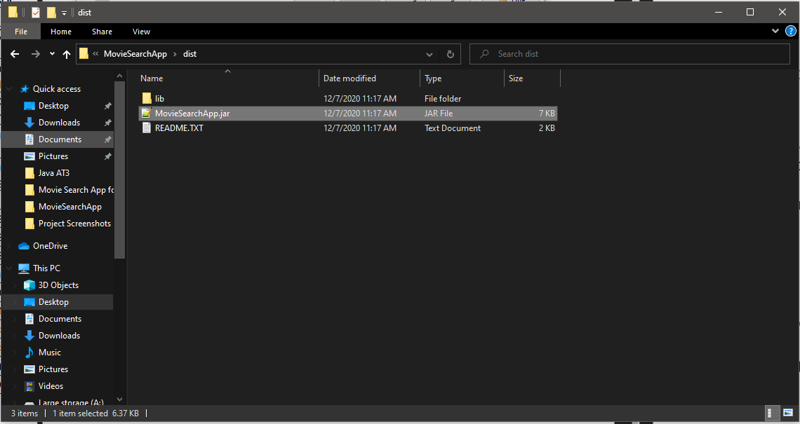

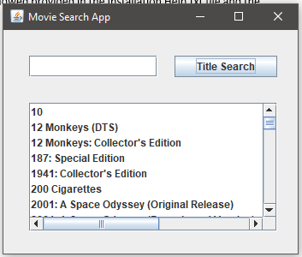

# Application Installation

Because the program runs in an excitable jar file installing application would be downloading on the clients website or can be emails, once the programs is downloaded right click on the Move search App.jar and click open with OpenJDK platform binary this will run the program with java.

# Removing The program

Removing or uninstalling the program from the user’s computer was made simple, because the program runs on an executable jar files the user just needs to find where the jar file is location and right click on the folder and press delete.

# Database Deployment

Within the product file the database will be contained there, the client will be provided with instructions of how to install the and import the dvd_titles.sql into the database, having the dvd_titles.sql in the database is essential for the application to work.

# Application Configuration

A Config file is supplied with the application. This configuration file is used to with the program to connect to the database which the programs pulls data from, each variables stores some information needed to connect to the database.

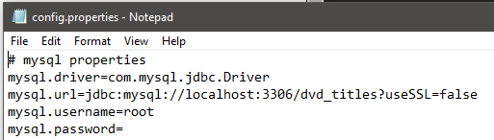

# Security Features

The No major security features are needed as the program will be running on the clients computer, when running the program for the first time on a new computer it may ask for permission to run and use a the java environment as it is a java application, click allow or input your password and the program should work as intended.